The Logistics of Supplying Single vs. Multi-crop Cellulosic Feedstocks to a Biorefinery in Southeast North Dakota

Thein A. Maung ^{a,*}, Cole R. Gustafson ª, David M. Saxowsky ª, John Nowatzki ^{b}, Tatjana Miljkovic ^{c}, David Ripplinger ª

Abstract
This study investigates the economics of supplying cellulosic crop residue feedstocks within 100 mile (or 161 km) radius of a potential new biorefinery in southeast North Dakota. We utilize linear programming transportation models and GIS (Geographic Information System) maps to identify optimal cellulosic feedstock supply sites for the biorefinery. Our evidence indicates that future crop residue removal policy will be important in assessing economic viability of harvesting crop residues for biofuel production. An increase in residue removal rate would narrow the size of supply areas required to provide total feedstock need for the biorefinery and consequently result in reducing transportation costs. There is an economic tradeoff between residue collection density and distance from the biorefinery. When multiple residue feedstocks are considered, this analysis is complicated further because greatest densities for each crop are not in similar regions. Overall, our findings show that higher costs savings can be achieved if multiple feedstocks are employed to produce cellulosic biofuels. In addition, feedstock supply risks can be lower with the use of multiple feedstocks.

Key words: cellulosic feedstock, corn stover, density, transportation cost, GIS, wheat straw

1. Introduction
The Energy Independence and Security Act of 2007 (EISA) defines three classes of biofuels: conventional, advanced, and cellulosic. These classes are differentiated based on potential reduction of greenhouse gas (GHG) emissions of 20, 50, and 60 percent respectively. Cellulosic biofuels are shown to have higher GHG offset rates than grain-based biofuels [1]. Thus, comparatively more GHG can be reduced using cellulosic feedstocks such as wheat straw and corn stover than corn grain to produce biofuels like ethanol. Because of its potential in reducing GHG emissions, wheat-straw or corn-stover based ethanol would be qualified as cellulosic biofuel per the federally mandated renewable fuels standard. By 2022, cellulosic ethanol production of 21 billion gallons per year will be required, creating a niche market opportunity. Almost all ethanol production in the United States utilizes corn grain as feedstock and rising corn prices coupled with lower GHG offset rates for conventional grain-based ethanol are encouraging current and potential ethanol producers to develop cellulosic biofuels that qualify under EISA.
Presently, a local energy company in North Dakota is partnering with an international cellulosic ethanol leader to develop and build a cellulosic biorefinery with 20MGY (Million Gallon per Year) or 0.076 hm³y⁻¹ production capacity in southeast region of the state. The biorefinery plans to convert wheat straw and corn stover into a variety of higher value energy products including cellulosic ethanol. The primary purpose of this research is to evaluate the logistics of sourcing wheat straw and corn stover within 100 mile (or 161 km) radius of the biorefinery by looking into feedstock delivered costs and by identifying potential feedstock supply sites.
Using a variety of research methods, many studies have investigated issues related to feedstock logistics and facility locations. In their study of switchgrass-based biofuel supply chain, Zhang et al. [2] used a mixed integer linear programming model to minimize the total switchgrass-based bioethanol supply chain cost by determining the optimal level of the various supply chain logistics decision variables. By employing a simulation model based on the framework of Integrated Biomass Supply Analysis and Logistics (IBSAL), Mobini et al. [3] evaluated the logistics and cost of supplying forest biomass to a potential power plant, the equilibrium moisture content, and carbon emissions from the operations. Wu et al. [4] constructed a mixed-integer programming model to examine the economic feasibility of siting a woody biomass-based ethanol facility in the central Appalachian hardwood region. Rentizelas and Tatsiopoulos [5] developed a hybrid optimization method which simulates and optimizes the system operation consisting of the biomass supply chain, the bioenergy conversion plant and the district heating and cooling network. Bai et al. [6] used a mixed-integer non-linear programming model and the traffic assignment model to simultaneously address bio-refinery location and shipment routing decisions under traffic congestion.
To demonstrate geographic variability and help understand the supply and cost issues, GIS has been introduced and integrated with mathematical programming and other methods to estimate biofeedstock supplies and costs. For example, Sultana and Kumar [7] developed a mathematical programming transport model in GIS environment to locate pellet plant facilities through integration of environmental and economic constraints in Alberta, Canada. Graham et al. [8] incorporated GIS into their modeling system and used it to estimate potential energy crop supplies and costs in eleven US states. Noon et al. [9] used a GIS-based methodology to identify promising locations for switchgrass-to-ethanol conversion plants in the context of biomass resource assessment. Using a similar approach, Zhan et al. [10] investigated the economic feasibility of locating a switchgrass-based ethanol facility in Alabama. Shi et al. [11] used GIS and remote sensing to evaluate the feasibility of setting up new biomass power plants and optimizing the locations of plants in China.
This paper conducts a case study of cellulosic biomass feedstock availability and logistics in North Dakota. Unlike aforementioned studies, the location of biorefinery is known in this paper. The problem is how to optimally determine the locations of feedstock supply sites which can provide feedstock needs for the biorefinery. This study uses linear programming transportation models and GIS maps to develop an innovative approach to locating potential feedstock supply sites within a reachable distance of the planned biorefinery in southeast North Dakota. Since biomass feedstock is usually dispersed over a wide range of areas, transportation cost can become a factor that limits the supply of feedstock [9,11,12,13]. To minimize transportation cost, we limit the feedstock supply area to a 100-mile radius using GIS. We then divide the area into numerous small square grids of land (i.e. potential feedstock supply sites). In each supply site we identify the density and yield of feedstock which are used to formulate transportation distance and cost estimates.
Our research seeks to contribute to growing literature on the logistics of biomass feedstock study. By employing a combination of cost-minimizing transportation models and GIS maps, we visually show that the total number of feedstock supply sites within the 100-mile radius zone can be reduced to an optimal level sufficient to supply all feedstock requirements for the biorefinery. We visually and numerically illustrate that there exists an economic tradeoff between the density and the distance of feedstock collection by imposing the feedstock density assumption on our models. Our research is conducted based on three feedstock supply or usage scenarios: i) 100 percent wheat straw, ii) 100 percent corn stover, and iii) a combination of wheat straw and corn stover. More importantly from a policy perspective, our findings suggest that USDA NRCS’s (United States Department of Agriculture-Natural Resources Conservation Service) future crop residue removal policy will play a vital role in determining the feasibility of using crop residues as potential feedstocks for biofuel production. To achieve our study objective, we first describe geographic area for feedstock supply in the following second section. Section three describes the methodology needed to determine optimal hauling costs and location of supply sites. Section four describes the assumptions and data used in our study. Empirical results are interpreted in section five and section seven concludes our study.

2. Geographic area for potential crop residue collection within 100-mile radius of biorefinery
The geographic area within a 100-mile radius from the biorefinery (our focal point) is defined utilizing GIS software (Fig. 1). The counties in this area are located in three states: North Dakota (ND), South Dakota (SD) and Minnesota (MN). Twenty eight counties are in southeast and northeast regions of ND, accounting for 90% of the total area of interest. Sixteen of these counties are fully enclosed in the area of interest. Four additional counties which include Polk, Norman, Clay and Wilkin counties are located in northwest MN, contributing 4% to the total area. Moreover, four counties in SD which includes McPherson, Brown and Marshall counties contribute 6% to the total area of interest. For each county, the percent of contribution to the 100-miles radius area is calculated using GIS utilities. Each small square grid in Fig. 1 represents a distance of 5 x 5 miles (or 8 x 8 km). The density of each crop in each 5-mile (or 8 km) square grid is obtained by dividing total harvested acres by total land acres of each crop in the area. To minimize wheat straw/corn stover hauling costs, the feedstocks should be sourced from nearby counties with the greatest yield density. Fig. 1 shows that geographically, the density or concentration of wheat straw/corn stover is higher in the northern/southern part of the biorefinery. This suggests that more straw/stover can be acquired with lower production cost and more assurance in the areas with higher yield density. But the drawback is that more distance would have to be traveled to collect straw/stover in the north/south which would result in an increase in transportation cost. Hence, the two criteria of density and distance represent an economic tradeoff in this case.
3. Methodology
3.1 Transportation model for individual wheat straw and corn stover
The following cost minimization transportation model considers hauling either 100% wheat straw or 100% corn stover from farm supply points located throughout ND, MN and SD to the biorefinery, the demand point. The objective function (Eq. (1.1)) depicts total cost minimization across all possible shipment routes for either straw or stover.
$Minimize{ ∑}_{i}∑_{j}{C_{ij}X}_{ij}$ (1.1)
$subject to ∑_{i} X_{ij}≥D_{j} for all j$ (1.2)
$∑_{j} X_{ij}≤S_{i} for all i$ (1.3)
$$X_{ij}≥0 for all i and j$$
In specifying the model, information about feedstock supply and demand points are denoted as i and j respectively. Parameter C_{ij} denotes the cost of delivering one ton of wheat straw/corn stover from the supply point i to the demand point j. The quantity of wheat straw/corn stover hauled from each supply point to the demand point will be designated as X_{ij}. Parameter D_{j} represents the total quantity of either 100% wheat straw or 100% corn stover demanded at the demand point j. The demand constraint (Eq. (1.2)) requires the sum of incoming shipments to the demand point j from all possible supply points i to be greater than D_{j}. Parameter S_{i} denotes the quantity of wheat straw/corn stover available at each supply point i. The supply constraint (Eq. (1.3)) requires the sum of outgoing shipments from the i^{th} supply point to the demand point j to be no greater than S_{i}. Implicitly, the model assumes a perfectly competitive feedstock market and the feedstock suppliers cannot charge the demander more than the market price plus the shipping cost. In other words, differences in feedstock market prices would only reflect the differences in hauling costs between locations.
3.2 Transportation model for a combination of wheat straw and corn stover
This model involves hauling a combination of wheat straw and corn stover to the biorefinery. For example, the hauling combination could be 50% wheat straw and 50% corn stover or 30% wheat straw and 70% corn stover. The cost minimization problem can be modified from above and written as:

$Minimize { ∑}_{i}∑_{j}e_{ij}Y_{ij}+∑_{i}∑_{j}h_{ij}Z_{ij}$ (2.1)
$subject to ∑_{i}Y_{ij}≥D_{j1} for all j$ (2.2)
$∑_{i}Z_{ij}≥D_{j2} for all j$ (2.3)
$∑_{j}Y_{ij}≤S_{i1} for all i$ (2.4)
$∑_{j}Z_{ij}≤S_{i2} for all i$ (2.5)
$$Y_{ij}≥0 ; Z_{ij}≥0 for all i and j$$
The objective function (Eq. (2.1)) depicts total cost minimization across all possible shipment routes for a combination of both straw and stover. Y_{ij} (Z_{ij}) is denoted as the quantity of wheat straw (corn stover) hauled from each supply point i to the demand point j. The parameters, e_{ij} and h_{ij}, are costs of hauling each ton of wheat straw and corn stover from each supply point i to the demand point j. D_{j1} and D_{j2} are quantities of wheat straw and corn stover demanded at the demand point j. S_{i1} and S_{i2} are quantities of wheat straw and corn stover available at each point i. Eqs. (2.2) and (2.3) are the demand constraints and Eqs. (2.4) and (2.5) are the supply constraints for straw and stover respectively. Data required to estimate above model are total hauling costs from each supply point to the demand point and the availability of straw and stover in each supply location in the study area. The amount of straw and stover available in each supply location is generated using GIS application. Hauling costs are estimated using the method discussed in the following section.
3.3 Estimation of wheat straw and corn stover availability
The value of crop residues for erosion control and soil fertility maintenance has been
well documented for all agricultural regions in the U.S. [16]. Residues control
erosion by reducing the impact of wind and water on soil particles. Erosion would
increase significantly if crop residues were completely removed. In turn increased erosion
would reduce soil fertility by carrying away nutrients in the soil sediments and deplete the soil organic carbon pool [17,18,19]. Wind erosion is a serious problem in ND, especially in the eastern part of the state [20,21]. Crop residue cover is important for preventing wind erosion following harvest. The amount of straw/stover that can be removed for biofuel production can be estimated using the following equation:
R = Grain Yield × Weight × SGR× Removal%× [1-Moisture%] (3)
R is the quantity of removable straw/stover in dry ton per acre. Grain yield is the weighted average yield of grain crop in bushels per acre. Weight is the weight of grain in short ton per bushel converted by dividing bushel weight of 56 pounds per bushel with 2,000 pounds per short ton. Based on Lal [22], SGR is defined as a straw/stover-to-grain ratio and it is assumed to be 1:1.5 for wheat straw and 1:1 for corn stover. Removal% is the percent of straw/stover that can be removed for biofuel production after considering wind erosion and soil fertility factors. Based on our discussions with USDA NRCS staff in ND, we assume that a maximum of 25 percent of straw/stover can be removed from farm fields. Moisture% is the percent of moisture content contained in straw/stover and is assumed to be 10 percent for straw and 27.5 percent for corn stover based on a confidential source. Grain yield data for wheat and corn are obtained from the USDA National Agricultural Statistics Service. The yield data are based on the five-year (2005 to 2009) average data by county in ND, SD and MN.
3.4 Field-to-storage and storage-to-plant distance
As indicated, the above transportation models minimize total hauling costs of crop residues delivered to the plant. It determines optimal farm supply or storage locations based on hauling distance, density and yield of residue, and the size of storage. The models begin with calculation of distance. Given a square grid system of roads as described in [23,24], the average distance (D) from farm field to storage can be estimated as:
D = 0.4714 × [M / (640 × Den × Yld)] exp(1/2) (4)
where M is defined as fixed amount of residue supplies (in ton) available from each farm storage supply site. The factor “640” represents the number of acres in a square mile and “0.4714” is the result of derivation from a square grid road system formulation (see [23]). Den is denoted as the density of residue acres. It is estimated by dividing total harvested acres of crop residue by total land acres in a given area. Yld is defined as a harvestable residue yield (in ton per acre).
For the purpose of finding optimal farm supply sites using aforementioned models, we assume that in the beginning there are a total of 1,313 feedstock supply sites within 100 mile radius of the biorefinery (as indicated in Fig. 1) and that each site is required to supply M tons of feedstock to the biorefinery. It is assumed that the 20MGY biorefinery requires a total of 480,000 tons of feedstock (either wheat straw or corn stover or a combination of both) supply annually. If each site can supply an equal amount of residue feedstock, this would suggest 363 tons per site. The number of farm supply sites is then reduced to an optimal level using our transportation models. Eq. (4) takes into account feedstock density and yield for each site when calculating field to storage hauling distance (D). The hauling distance from field to storage site is estimated using Eq. (4). Straight line distance from each supply or storage site (i.e. each centroid of a square grid) to the biorefinery is estimated using GIS. A road winding factor of 30% is considered when estimating field-to-storage and storage-to-plant hauling distances.

4. Assumptions and data description
We assume that farmers will harvest wheat/corn grain first and then leave straw/stover on the ground for collection later. In North Dakota, farm producers neither have time nor labor to collect straw/stover themselves, necessitating the use of custom operators [25]. The collection process begins with a custom baler that windrows straw/stover, if necessary, followed by baling. A large square baler picks up straw/stover, compacts it and ties the feedstock in the form of large square bales. Each square bale is assumed to be 3’ high, 4’ wide and 8’ long, weighing 900 lbs (0.45 ton). The goal is to estimate the cost of moving 1.07 million (480,000 tons) square bales from various fields within 100 mile radius to the biorefinery. It is assumed that after baling is completed, the process of moving wheat straw will be a multi-step process. First, square bales are collected from the fields and stacked on roadside. They are subsequently loaded onto trucks and driven to nearby storage supply sites for unloading, stacking and tarping for rain protection. In this study, it is assumed that supply sites where the bales are temporarily stored will be located near farm fields. This scenario reduces the amount of land needed for storage at the plant and allows hauling to the plant to occur year-round. The last step will be to load bales onto trucks using a loader and transport them to the final destination for further processing and energy conversion. In order to obtain total transportation cost; we need to estimate farm-to-storage and storage-to-plant transportation costs.
4.1 Transportation cost
Transportation cost can vary from one supply site to another because of differences in residue feedstock densities and distances traveled from farm to storage and storage to plant. Farm-to-storage transportation cost is influenced by hauling distance shown in Eq. (4). By employing harvest season trucking rate data (obtained from an existing commercial firm that gathers biomass on a large scale) and estimated farm-to-storage hauling distance data, we computed farm-to-storage transportation cost for each supply site within 100-mile radius of biorefinery for wheat straw and corn stover. Storage-to-plant transportation cost is derived for each supply site using non-harvest trucking rate data and storage-to-plant hauling distance data. Total transportation cost is calculated for each supply site for wheat straw and corn stover using farm-to-storage transportation cost, storage-to-plant transportation cost, and loading/unloading cost. Because of the magnitude of estimated transportation cost data (a total of 1,313 data points), we report them by county average for ND in Table 1. The table shows that the state average total transportation cost for straw and stover is close to $20 per ton.
5. Results
By incorporating the specified data and assumptions into the models, optimal results are generated and discussed below.
5.1 100% wheat straw estimation
The transportation model for this case minimizes hauling costs across all possible shipment routes within 100-mile radius of the biorefinery. Estimated results are reported in Fig. 2 (a, b and c) for a 25% residue removal rate. In the figure, we imposed three assumptions for density requirement: a) no minimum density requirement, b) minimum density requirement of 15%, and c) minimum density requirement of 25%. All the wheat straws in green areas in each figure sum up to 480,000 tons required by the biorefinery. As can be seen in Fig. 2 (a), all wheat straw demand needs are obtainable within 60 to 65 mile radius zone. However, this scenario is unrealistic because it is under the assumption that even low-yield density areas provide affordable wheat straws. In reality, it would be costly to collect residues in the low-yield density areas due to diseconomies of scale of collecting [14,15]. To generate more realistic outcomes, minimum density requirements are imposed on the model. Fig. 2 (b) shows that when the minimum density requirement of 15% is imposed on the model, potential wheat straw supply locations are scattered around the biorefinery with most of them being concentrated in the north, especially in counties like Wells, Foster, Griggs, Steele, Nelson, Grand Forks, Barnes and some areas in Stutsman. Fig. 2 (c) depicts the supply locations if the minimum density requirement of 25% is imposed. Predictably, as a result of imposing higher density assumptions, the sites where most wheat straws are available move farther north.
In a sense, there is an economic tradeoff between density and distance. North Dakota counties located farther in the north have higher yield density of wheat straws than the counties located in the middle or the south. In order to secure more wheat straw supplies in the north, more distances would need to be traveled. As a consequence, transportation costs would increase. This is numerically illustrated in Table 2 which reports total optimal hauling costs for wheat straw by yield density and removal rate assumptions. If we increase wheat straw removal rate from 25% to 50%, the supply areas required to provide all wheat straw needs for the biorefinery are shrunk significantly which then would lower hauling costs (GIS map results for this 50% removal case are available upon request). Table 2 also indicates that if the straw removal rate increases to 50%, hauling cost of more than $600,000 can be saved annually for all density assumptions.
5.2 100% corn stover estimation
Estimated results for this scenario are reported in Fig. 3 (a, b and c) if the biorefinery would operate on 100% corn stover. The results can be interpreted in a manner similar to that described in the preceding 100% wheat straw scenario. The figure shows that potential sources of corn stover will most likely come from the counties located in the east and southeast of the biorefinery such as Steele, Traill, Barnes, Cass, LaMoure, Ransom, and Dickey. Richland County has the highest concentration of corn stover, but the hauling distance is greater. Optimal transportation costs are reported in Table 3 for stover removal rate of 25% and 50% respectively. The table also shows that if the stover removal rate increases to 50%, higher feedstock cost savings can be achieved annually.
5.3 Combination of 50% wheat straw and 50% corn stover estimation
As discussed in the methodology section, the transportation model is modified for this combined (or multi-feedstock) scenario and estimated results are reported in Fig. 4 (a, b and c). By comparison, the main difference between the individual 100% wheat (straw) or 100% corn (stover) scenario (Fig. 2 and 3) and this 50%wheat-50%corn combined scenario (Fig. 4) is that the latter reduces the supply areas required to collect the feedstocks and hence results in lower optimal hauling costs as shown in Table 4. A combination of feedstock is likely a viable alternative given that the technology is already available to produce cellulosic biofuels using both straw and stover. Table 4 also shows that optimal hauling costs are not significantly different among wheat-corn combination scenarios themselves, especially between 50%Wheat-50%Corn and 60%Wheat-40%Corn scenarios.
5.4 Potential optimal availability of wheat straw and corn stover
Based on above cost comparisons, the 50%Wheat-50%Corn scenario is used as a benchmark to report estimated results for straw and stover availability. The optimal amounts of straw and stover available for energy production are shown by county in Table 5. A map to illustrate this table is depicted in Fig. 4(b). The table shows that 85% of total feedstock needs will come from Barnes, Cass, Foster, Griggs, LaMoure, Steele, Stutsman and Wells counties.

6. Policy Implications and Conclusions
An interesting constraint that emerged during our project evaluation was USDA NRCS’s policy on crop residue removal. To understand provisions NRCS might apply to wheat straw removal across varying topographies in the study region, we held a meeting with NRCS staff in North Dakota. Most farms in the study region contain erodible land which requires a NRCS soil conservation plan. Due to the concerns with soil erosion and fertility loss, NRCS suggested that the amount of crop residue that can be removed from the field can be very limited. Although NRCS is still mindful of highly erodible land characteristics and the potential for wind/water erosion, its primary focus now is on soil carbon or organic matter. Consequently, the amount of crop residues remaining after harvest to guard against either wind or water erosion are now secondary considerations.
The NRCS’s emerging policy is to recommend that 2-3,000 lbs of carbon organic matter remain in or on the soil after harvest, regardless of crop, for soil carbon maintenance. However if low residue crops like soybeans or sugar beets are planted in rotation with wheat and do not leave enough residue-generated carbon in soil, their annual deficit must be made up with wheat straw from rotational crops in succeeding years. Since soybeans are widespread in the region, the amount of wheat straw available for collection is reduced because the straw must replace carbon organic matter removed by the soybean enterprise.
In most regions, NRCS would recommend against harvesting wheat straw for biofuel production if soybeans are raised in rotation. This is not just an issue for wheat straw. A recent USDA-ARS (Agricultural Research Service) study also found that recommended stover collection from corn in rotation with soybeans is also quite limited in Iowa [26]. A further restriction is that requirements are imposed by field, unlike the past where only the select areas susceptible to erosion within a field were primary concerns. While most fields have only portions that are at risk for erosion, soil carbon requirements will likely be imposed field wide. Thus, USDA appears to be sending mixed messages with respect to development of cellulosic biofuel. On one hand USDA is publicly supporting the development of cellulosic biofuel industry. However, the agency also is implementing new environmental policy that has the potential to significantly constrain gathering of biofuel feedstock materials.
Our findings indicate that increase in residue removal rate would narrow the size of supply areas needed to provide total feedstock requirement for the biorefinery. As a result, transportation costs are reduced. However, higher removal rates run counter to USDA NRCS recommendations. NRCS’s future crop residue removal policy will be one of the key factors that determine the feasibility of harvesting crop residues as potential biomass feedstocks for energy generation. Our evidence shows that there is an economic tradeoff between residue yield density and distance from the plant. When two or more crop residue feedstocks are available, this analysis becomes more complex as crop residue densities vary in disparate areas.
Our research shows that relying solely on one particular residue feedstock (either wheat straw or corn stover) for supply needs would likely require traveling longer distances which increases total hauling costs for the biorefinery. Employing a combination of straw and stover lowers total transportation costs. Costs are lowest with 50% wheat straw and 50% corn stover combination. Most straw and stover supply needs for the biorefinery can be met from nearby counties with relatively high feedstock density. Overall findings suggest that it would be in the best interest for a biorefinery firm to source multi feedstocks for cellulosic biofuel production because in doing so the firm can not only minimize transportation costs but supply risks associated with crop residue removal policy.

Acknowledgements
Funding for this research was provided by the Great River Energy Inc.

References
- McCarl BA, Maung TA, Szulczyk KT 2009. Could bioenergy be used to harvest the greenhouse: an economic investigation of bioenergy and climate change? In: Khanna M, Scheffran J, Zilberman D, editors. Handbook of bioenergy economics and policy. New York: Springer Publishing; 2009. p. 195-218.

- Zhang J, Osmani A, Awudu I, Gonela V. An integrated optimization model for switchgrass-based bioethanol supply chain. Appl Energy (2012), http://dx.doi.org/10.1016/j.apenergy.2012.06.054

- Mobini M, Sowlati T, Sokhansanj S. Forest biomass supply logistics for a power plant using the discrete-event simulation approach. Appl Energy 2011;88:1241-1250.

- Wu J, Sperow M, Wang J. Economic feasibility of a woody biomass-based ethanol plant in central Appalachia. J Agri & Res Econ 2010;35:522-544.

- Rentizelas AA, Tatsiopoulos IP. Locating a bioenergy facility using a hybrid optimization method. Int J Prod Econ 2010;123:196-209.

- Bai Y, Hwang T, Kang S, Ouyang Y. Biofuel refinery location and supply chain planning under traffic congestion. Transportation Research Part B 2011;45:162-175.

- Sultana A, Kumar A. Optimal siting and size of bioenergy facilities using geographic information system. Appl Energy 2012;94:192-201.

- Graham RL, English BC, Noon CE. A geographic information system-based modeling system for evaluating the cost of delivered energy crop feedstock. Biomass Bioenergy 2000;18:309-329.

- Noon CE, Zhan FB, Graham RL. GIS-based analysis of marginal price variation with an application in the identification of candidate ethanol conversion plant locations. Networks and Spatial Economics 2002;2:79-93.

- Zhan FB, Chena X, Noon CE, Wu G. A GIS-enabled comparison of fixed and discriminatory pricing strategies for potential switchgrass-to-ethanol conversion facilities in Alabama. Biomass Bioenergy 2005;28:295-306.

- Shi X, Elmore A, Li X, Gorence NJ, Jin H, Zhang X, Wang F. Using spatial information technologies to select sites for biomass power plants: A case study in Guangdong Province, China. Biomass Bioenergy 2008;32:35-43.

- Noon CE, Daly MJ. GIS-based biomass resource assessment with BRAVO. Biomass Bioenergy 1996;10:101-109.
- Ranta T. Logging residues from regeneration fellings for biofuel production - A GIS-based availability analysis in Finland. Biomass Bioenergy 2005;28:171-182.

- Bransby DI, Sladden SE, Downing M. Yield effects on bale density and time required for commercial harvesting and baling of switchgrass. In: Proceedings, BIOENERGY ’96 - The 7th National Bioenergy Conference: Partnerships to Develop and Apply Biomass Technologies, Nashville, Tennessee, 15-20 September, 1996.

- Sokhansanj S, Mani S, Turhollow A, Kumar A, Bransby D, Lynd L, Laser M. Large-scale production, harvest and logistics of switchgrass (Panicum virgatum L.) - current technology and envisioning a mature technology. Biofuels, Bioprod. Bioref. 2009;3:124-141.

- Larson WE. Crop residues: energy production or erosion control? J Soil & Water Cons. 1979;34:74-76.

- Holt RF. Crop residue, soil erosion, and plant nutrient relationships. J Soil & Water Cons 1979;34:96-98.

- Pimentel D, Moran MA, Fast S, Weber G, Bukantis R, Balliet L, Boveng P, Cleveland C, Hindman S, Young M. Biomass energy from crop and forest residues. Science 1981; 212:1110-15.

- Lal R. Soil erosion and the global carbon budget. Env Int 2003;29:437-50.
- Cihacek LJ, Sweeney MD, Deibert EJ. Characterization of wind erosion sediments in the Red River Valley of North Dakota. J Env Quality 1993;22:305-10.

- Van Donk SJ, Merrill SD, Tanaka DL, Krupinsky JM. Crop residue in North Dakota: measured and simulated by the Wind Erosion Prediction System. American Soc Agri & Bio Eng 2008;51:1623-32.

- Lal R. World crop residues production and implications of its use as a biofuel. Env Int 2005;31:575-584.

- French BC. Some considerations in estimating assembly cost functions for agricultural processing operations. J Farm Econ 1960;42:767-78.

- McCarl BA, Adams DM, Alig RJ, Chmelik JT. Competitiveness of biomass-fueled electrical power plants. Annals Oper Res 2000;94:37-55.

- Maung TA, Gustafson CR, Saxowsky DM, Miljkovic T, Nowatzki JF. Market information on sourcing cellulosic feedstock for biofuel production in northern plains region of the United States. J Agri Sci & Tech A 2012;2:10-23.

- Karlen DL, Birrell SJ, Radtke CJ, Wilhelm WW. Crop residue removal effects on production costs and soil quality. In: ASA-CSSA-SSSA Annual Meeting, Indianapolis, Indiana, 12-16 November, 2006.

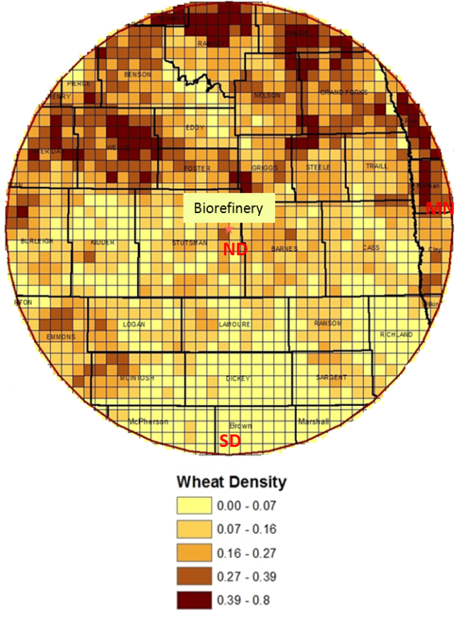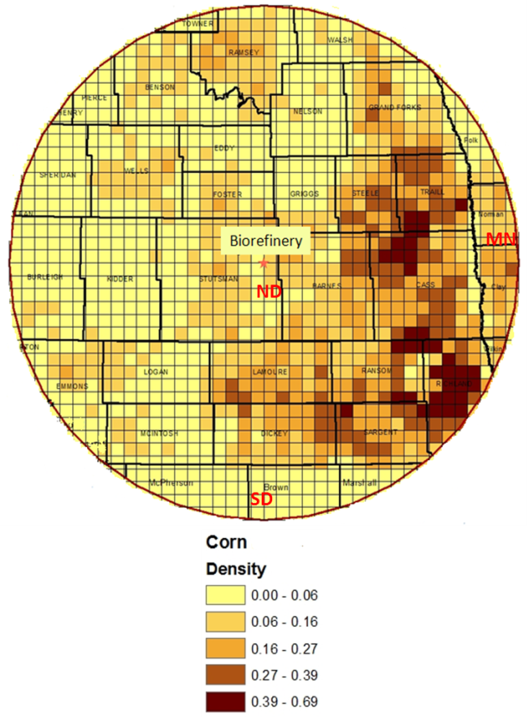

Fig. 1. Wheat and corn concentration within 100-mile radius of biorefinery

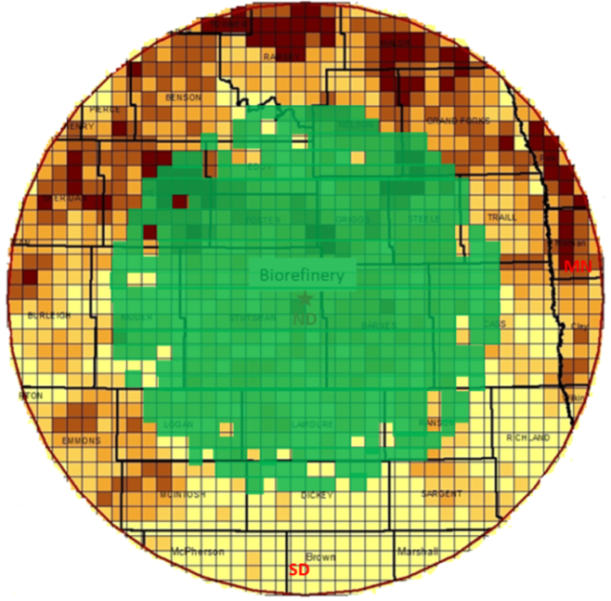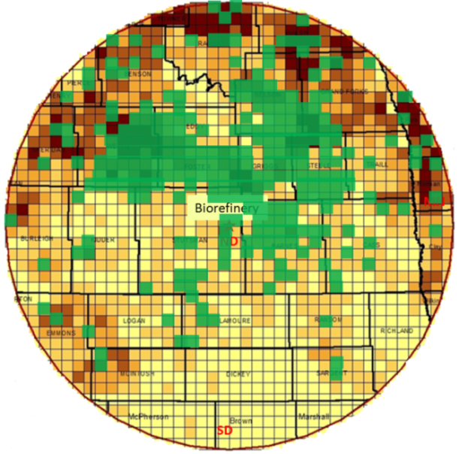

(a) No density requirement (b) Density requirement of at least 15%

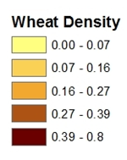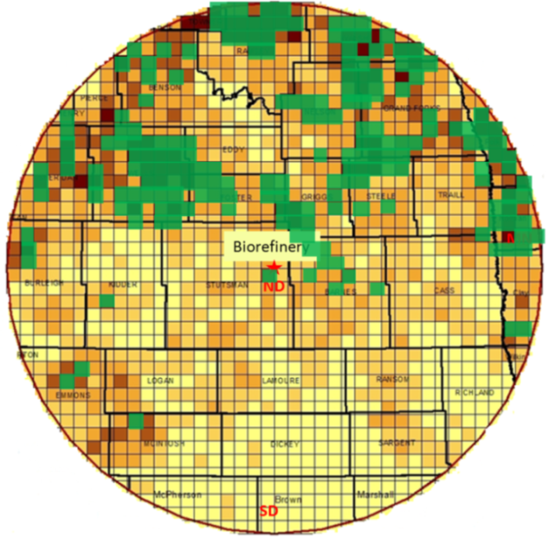

(c) Density requirement of at least 25%

Fig. 2. Estimated potential wheat straw supply sites (assumed 25% removal rate)

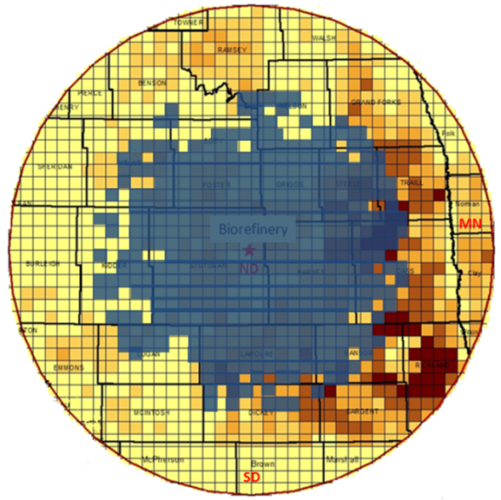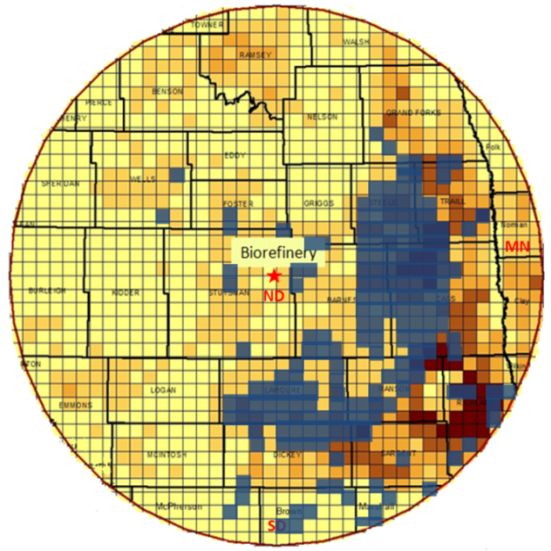

(a) No density requirement (b) Density requirement of at least 15%

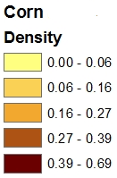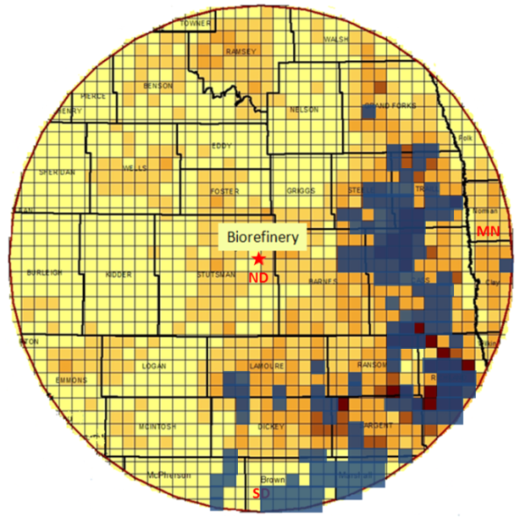

(c) Density requirement of at least 25%

Fig. 3. Estimated potential corn stover supply sites (assumed 25% removal rate)

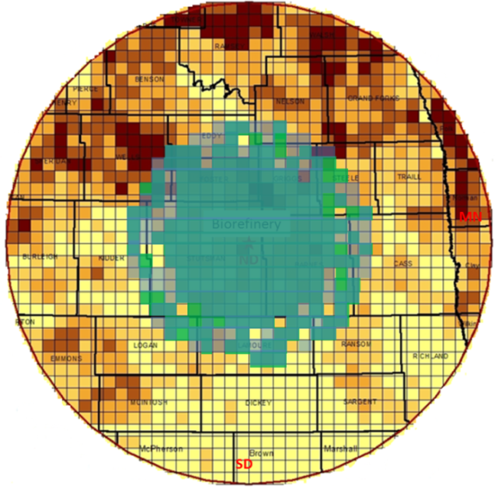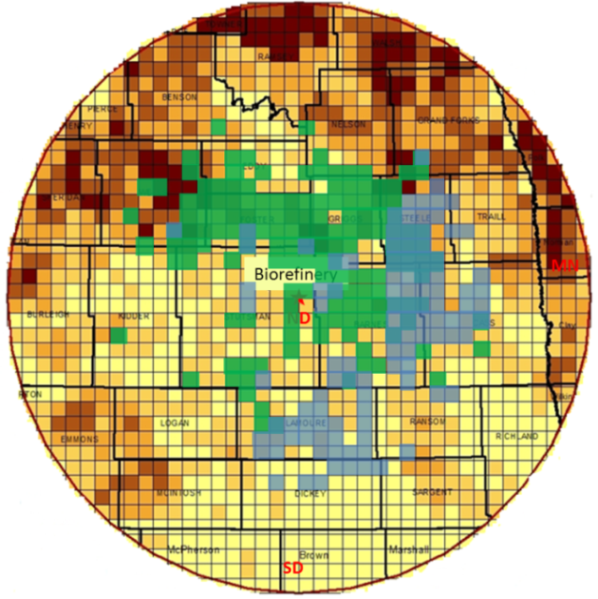
(a) No density requirement (b) Density requirement of at least 15%

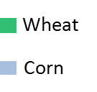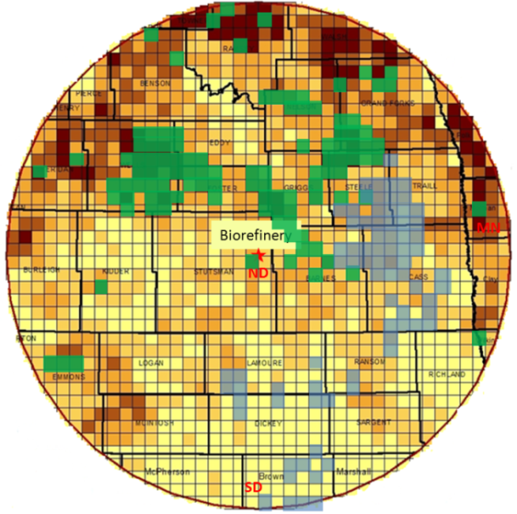
(c) Density requirement of at least 25%

Fig. 4. Estimated potential wheat straw (50%) and corn stover (50%) supply sites (assumed 25% removal rate)

Table 1 Total transportation cost by county in North Dakota
 | Total Transportation Cost ($/ton)
County | Wheat Straw | Corn Stover
Barnes | 15.61 | 15.61
Benson | 20.52 | 20.63
Burleigh | 20.83 | 21.20
Cass | 19.74 | 19.74
Dickey | 20.66 | 20.25
Eddy | 18.26 | 18.33
Emmons | 21.18 | 20.99
Foster | 16.50 | 16.50
Grand Forks | 20.63 | 20.63
Griggs | 16.23 | 16.23
Kidder | 19.09 | 19.39
La Moure | 17.85 | 17.85
Logan | 19.46 | 19.71
McHenry | 20.79 | 22.27
McIntosh | 20.71 | 20.82
Nelson | 19.45 | 19.45
Pierce | 20.79 | 21.71
Ramsey | 20.73 | 20.73
Ransom | 19.89 | 19.45
Richland | 21.25 | 20.79
Sargent | 21.04 | 20.79
Sheridan | 20.85 | 21.77
Steele | 18.24 | 18.24
Stutsman | 15.10 | 15.13
Towner | 20.79 | 20.79
Traill | 20.28 | 20.28
Walsh | 20.79 | 20.95
Wells | 19.69 | 19.69
Average | 19.53 | 19.64

Table 2 Optimal transportation cost (in Million US Dollars) for 100% wheat straw

 | Removal Rate
Density Assumption (%) | 25% | 50%
Zero | $ 8.30 | $ 7.61
At least 15% | $ 8.78 | $ 7.96
At least 25% | $ 9.37 | $ 8.72

Table 3 Optimal transportation cost (in Million US Dollars) for 100% corn stover
 | Removal Rate
Density Assumption (%) | 25% | 50%
Zero | $ 8.43 | $ 7.78
At least 15% | $ 9.06 | $ 8.56
At least 25% | $ 9.56 | $ 9.15

Table 4 Comparison of optimal transportation cost (in Million US Dollars)

 | Density Requirement Constraint
Scenario | Zero | At Least 15% | At Least 25% | Average
100% Wheat | $ 8.30 | $ 8.78 | $ 9.37 | $ 8.82
100% Corn | $ 8.43 | $ 9.06 | $ 9.56 | $ 9.02
50%Wheat-50%Corn | $ 7.70 | $ 8.26 | $ 8.96 | $ 8.31
60%Wheat-40%Corn | $ 7.70 | $ 8.26 | $ 8.97 | $ 8.31
70%Wheat-30%Corn | $ 7.74 | $ 8.26 | $ 9.05 | $ 8.35
40%Wheat-60%Corn | $ 7.71 | $ 8.29 | $ 8.97 | $ 8.32
30%Wheat-70%Corn | $ 7.80 | $ 8.37 | $ 9.04 | $ 8.40

Table 5 Optimal availability of wheat straw and corn stover in North Dakota

County | Wheat Straw (ton) | Corn Stover (ton) | Total (ton) | Total (%)
Barnes | 39,417 | 45,335 | 84,751 | 17.66
Benson | 1,914 | - | 1,914 | 0.40
Cass | 7,346 | 53,074 | 60,420 | 12.59
Dickey | - | 17,705 | 17,705 | 3.69
Eddy | 10,361 | - | 10,361 | 2.16
Foster | 37,321 | 1,773 | 39,094 | 8.14
Grand Forks | 7,669 | 1,355 | 9,024 | 1.88
Giggs | 38,199 | 3,371 | 41,570 | 8.66
Kidder | 5,614 | - | 5,614 | 1.17
LaMoure | 4,785 | 52,385 | 57,170 | 11.91
Nelson | 6,216 | - | 6,216 | 1.29
Ransom | - | 11,359 | 11,359 | 2.37
Steele | 21,138 | 36,407 | 57,544 | 11.99
Stutsman | 32,756 | 7,184 | 39,940 | 8.32
Traill |  | 8,955 | 8,955 | 1.87
Wells | 27,264 | 1,096 | 28,360 | 5.91
Total | 240,000 | 240,000 | 480,000 | 100.00

Throughout this article, we use the words ‘hauling’ and ‘transportation’ interchangeably.
Note: In SI unit, one acre equals to approximately 0.405 hectare.
Research studies [14,15] have shown that harvesting biomass feedstock in high-yield areas results in low production costs.
We assume that each supply or storage point (i) is located at the center of each five-mile square grid and there are about 1,313 five-mile square grids within a 100-mile radius of biorefinery. Thus, i = 1,…, 1,313.
j=1, since we have only one demand location.
The unit ‘ton’ in this paper represents short ton. One short ton equals to about 0.907 tonnes in SI unit.
We cannot reveal the source due to non-disclosure agreement.
Loading/unloading cost is $3.5 per ton obtained from the commercial firm.

